Cost-Effectiveness and Decision Modeling in R

PSA Markov Model Exercise

The DARTH workgroup

Developed by the Decision Analysis in R for Technologies in Health (DARTH) workgroup:

Fernando Alarid-Escudero, PhD (1)

Eva A. Enns, MS, PhD (2)

M.G. Myriam Hunink, MD, PhD (3,4)

Hawre J. Jalal, MD, PhD (5)

Eline M. Krijkamp, MSc (3)

Petros Pechlivanoglou, PhD (6,7)

Alan Yang, MSc (7)

In collaboration of:

1. Division of Public Administration, Center for Research and Teaching in Economics (CIDE), Aguascalientes, Mexico
2. University of Minnesota School of Public Health, Minneapolis, MN, USA
3. Erasmus MC, Rotterdam, The Netherlands
4. Harvard T.H. Chan School of Public Health, Boston, USA
5. University of Pittsburgh Graduate School of Public Health, Pittsburgh, PA, USA
6. University of Toronto, Toronto ON, Canada
7. The Hospital for Sick Children, Toronto ON, Canada

Please cite our publications when using this code:

* Jalal H, Pechlivanoglou P, Krijkamp E, Alarid-Escudero F, Enns E, Hunink MG. An Overview of R in Health Decision Sciences. Med Decis Making. 2017; 37(3): 735-746. <https://journals.sagepub.com/doi/abs/10.1177/0272989X16686559>
* Alarid-Escudero F, Krijkamp EM, Enns EA, Yang A, Hunink MGM Pechlivanoglou P, Jalal H. Cohort State-Transition Models in R: A Tutorial. arXiv:200107824v2. 2020:1-48. <http://arxiv.org/abs/2001.07824>
* Krijkamp EM, Alarid-Escudero F, Enns EA, Jalal HJ, Hunink MGM, Pechlivanoglou P. Microsimulation modeling for health decision sciences using R: A tutorial. Med Decis Making. 2018;38(3):400–22. <https://journals.sagepub.com/doi/abs/10.1177/0272989X18754513>
* Krijkamp EM, Alarid-Escudero F, Enns E, Pechlivanoglou P, Hunink MM, Jalal H. A Multidimensional Array Representation of State-Transition Model Dynamics. Med Decis Making. 2020 Online first. <https://doi.org/10.1177/0272989X19893973>

Copyright 2017, THE HOSPITAL FOR SICK CHILDREN AND THE COLLABORATING INSTITUTIONS. All rights reserved in Canada, the United States and worldwide. Copyright, trademarks, trade names and any and all associated intellectual property are exclusively owned by THE HOSPITAL FOR Sick CHILDREN and the collaborating institutions. These materials may be used, reproduced, modified, distributed and adapted with proper attribution.

# Exercise I: Construct a Markov Model of the Sick-Sicker Disease

In this exercise, we will model a hypothetical disease that affects individuals with an average age of 25 years and results in increased mortality, increased healthcare costs, and reduced quality of life. The disease has two levels; affected individuals initially become sick but can subsequently progress and become sicker. Two alternative strategies exist for this hypothetical disease: a no-treatment and a treatment strategy. Under the treatment strategy, individuals in the sick and sicker states are treated until they recover (only if sick; individuals in the sicker state cannot recover) or die. The cost of the treatment is additive to the baseline healthcare costs of being sick or sicker. The treatment improves quality of life for those individuals who are sick but has no impact on the quality of life of those who are sicker. Unfortunately, it is not possible to reliably differentiate between people in the sick and sicker states, so treatment cannot be targeted to only those in the sick state. You are asked to evaluate the cost-effectiveness of the treatment.

To model this disease, we will rely on a state-transition cohort model, called the Sick-Sicker model, first described by Enns et al. The Sick-Sicker model consists of four health states: Healthy (H), two disease states, Sick (S1) and Sicker (S2), and Dead (D) (Figure 1). All individuals start in the Healthy state. Over time, healthy individuals may develop the disease and can progress to S1. Individuals in S1 can recover (return to state H), progress further to S2 or die. Individuals in S2 cannot recover (i.e. cannot transition to either S1 or H). Individuals in H have a baseline probability of death; individuals in S1 and S2 experience increased mortality compared to those in the H state, given in terms of hazard ratios. These ratios are used to calculate the probabilities of dying when in S1 and S2.

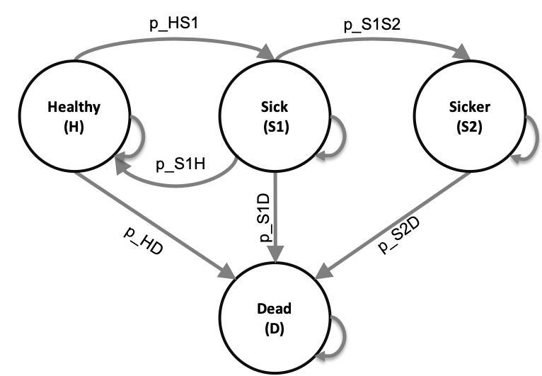

Schematic representation of the Sick-Sicker model

## Tasks

1. Build the Markov model in R for no treatment and treatment strategies.
2. Plot the survival curve for the cohort under no treatment.
3. Estimate the cost-effectiveness of treatment vs no-treatment.
4. Create a cost-effectiveness table with all results of interest.

**Table I: Input parameters**

|  |  |  |
| --- | --- | --- |
| **Parameter** | **R name** | **Value** |
| Time horizon | n_t | 30 years |
| Cycle length |  | 1 year |
| Names of health states | v_n | H, S1, S2, D |
| Annual discount rate (costs/QALYs) | d_r | 3% |
| Annual transition probabilities |  |  |
| - Disease onset (H to S1) | p_HS1 | 0.15 |
| - Recovery (S1 to H) | p_S1H | 0.5 |
| - Disease progression (S1 to S2) in the time-homogeneous model | p_S1S2 | 0.105 |
| Annual mortality |  |  |
| - All-cause mortality (H to D) | p_HD | 0.005 |
| - Hazard ratio of death in S1 vs H | hr_S1 | 3 |
| - Hazard ratio of death in S2 vs H | hr_S2 | 10 |
| Annual costs |  |  |
| - Healthy individuals | c_H | $2,000 |
| - Sick individuals in S1 | c_S1 | $4,000 |
| - Sick individuals in S2 | c_S2 | $15,000 |
| - Dead individuals | c_D | $0 |
| - Additional costs of sick individuals treated in S1 or S2 | c_trt | $12,000 |
| Utility weights |  |  |
| - Healthy individuals | u_H | 1.00 |
| - Sick individuals in S1 | u_S1 | 0.75 |
| - Sick individuals in S2 | u_S2 | 0.50 |
| - Dead individuals | u_D | 0.00 |
| Intervention effect |  |  |
| - Utility for treated individuals in S1 | u_trt | 0.95 |

*Note: To calculate the probability of dying from S1 and S2, use the hazard ratios provided. To do so, first convert the probability of dying from healthy, p_HD, to a rate; then multiply this rate by the appropriate hazard ratio; finally, convert this rate back to a probability. Recall that you can convert between rates and probabilities using the following formulas: $r=−loga(1−p)$ and $p=1−e^{(−rt)}$

# Exercise II: Probabilistic sensitivity analysis of the Sick-Sicker Markov model

This exercise continues based on the time-homogeneous deterministic Markov model of the Sick-Sicker model from Exercise I. In this exercise, you will do a probabilistic sensitivity analysis (PSA) with 1000 simulations (n_sim). The Table describes the distributions for the variables you used in the previous exercise.

**Table II: Input parameters for probabilistic analysis**

|  |  |  |
| --- | --- | --- |
| **Parameter** | **Distribution** | **Distribution values** |
| Number of simulation | n_sim | 1000 |
| Annual transition probabilities |  |  |
| - Disease onset (H to S1) | Beta | $α=30, β=170$ |
| - Recovery (S1 to H) | Beta | $α=60, β=60$ |
| - Disease progression (S1 to S2) in the time-homogeneous model | Beta | $α=84, β=716$ |
| Annual mortality |  |  |
| - All-cause mortality (H to D) | Beta | $α=10, β=1990$ |
| - Hazard ratio of death in S1 vs H | Lognormal | $μ=log(3), σ=0.01$ |
| - Hazard ratio of death in S2 vs H | Lognormal | $μ=log(10), σ=0.02$ |
| Annual costs |  |  |
| - Healthy individuals | Gamma | shape = 100.0, scale = 20.0 |
| - Sick individuals in S1 | Gamma | shape = 177.8, scale = 22.5 |
| - Sick individuals in S2 | Gamma | shape = 225.0, scale = 66.7 |
| - Additional costs of sick individuals treated in S1 or S2 | Gamma | shape = 73.5, scale = 163.3 |
| Utility weights |  |  |
| - Healthy individuals | Beta | $α=200, β=3$ |
| - Sick individuals in S1 | Beta | $α=130, β=45$ |
| - Sick individuals in S2 | Beta | $α=230, β=230$ |
| Intervention effect |  |  |
| - Utility for treated individuals in S1 | Beta | $α=300, β=15$ |

## Tasks

1. Create the calculate_ce_out R function of the Sick-Sicker Markov model in the file “Functions_markov_sick-sicker.R”.
2. Create a function called gen_psa to sample values for the uncertain parameters using the appropriate distributions.
3. Open the file “markov_sick-sicker_SA_template.R” and conduct a probabilistic Cost-Effectiveness analysis of treatment vs no-treatment.
4. Create histograms of model inputs.
5. Create a cost-effectiveness plane to present discounted costs and QALYs.
6. Create the cost-effectiveness acceptability curves (CEAC) and frontier (CEAF) for the treatment comparison assuming WTP thresholds of $\$0$ to $\$200,000$.
7. Create the expected loss curves (ELCs) plot
8. Create an expected value of perfect information (EVPI) plot.